Placemaking Wales Charter Fifth Anniversary Celebration Document Submission Form.

To be included in the celebration document please follow these steps:
- Fill in relevant sections in the boxes below with your information.
- Save this document as ‘your name.doc’.
- Provide either your company logo or a thumbnail portrait image as .jpg format
- Images: provide 1 (suggested) or 2 images to illustrate your response. If 1 image, image should be square/portrait format. If 2 images, please supply as landscape format. See layout options on the next page.
- Send the completed form, logo and image(s) to placemakingwales@dcfw.org by the 11th September 2025.
- Submissions can be made in English and/or Welsh. If you provide both you will have one page in each language, images must be the same for both.

Organisation name or your name as you want it displayed:

Enter text

Contact email address:

Enter text

Website address:

Enter text

Text on your organisation’s/personal response to the Placemaking Wales Charter over the last five years here (Maximum 125 words – be clear and succinct):

Enter text

A short sentence to be used as a pull quote on your page (Maximum 20 words - this will be used large pull quote on your individual page for impact):

Enter text
One-image option:
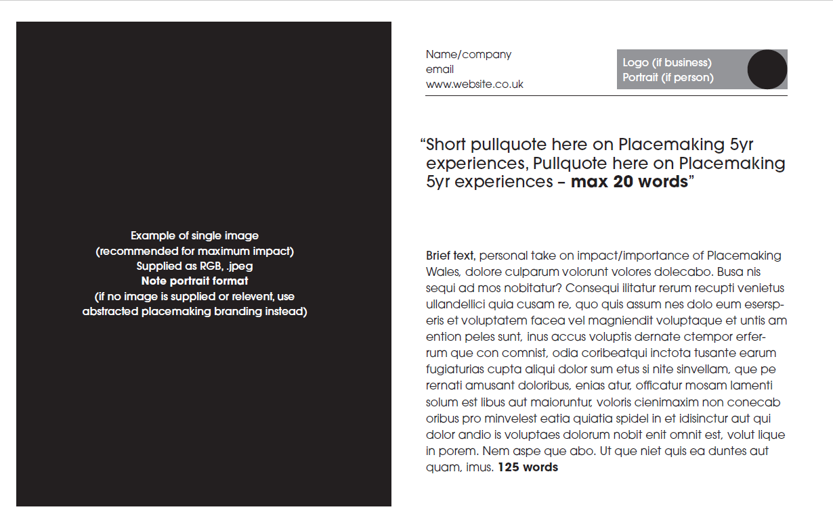

Two-image option:
